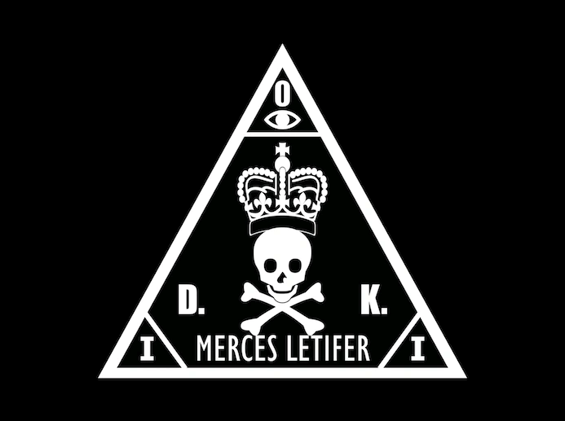
International Contract Agency
Assignment Report
Confidential, Do Not Distribute

Assignment Brief
Good job on finding William Kronx’s hotel, we have deployed agents to gather field intelligence on the target and his companions. Unfortunately, it seems like William has caught wind of ICA movement and has started to obfuscate his movements and meetups to prevent agents from keeping up with him.
We noticed that William has made a comment on one of the intern’s social media posts but deleted it before we were able to read it. Recover the original comment that William has made, maybe it contains some hints on the next meetup with his… business associates.
Objective(s)
- Recover the deleted comment, and figure out the new meetup point

